QUIJANO, GILL WHENZEL B. | 12261701

ROBELLON, JIREH G. | 12216283

TALICOL, MATTHEW CEAZAR | 122

LBYCPA1 - EQ4

03 - 30 - 2023

**LBYCPA1 BatmanProject (Draft)**

**Title:** “Code Crawler: An Educational Python Based Game”

**Short Description:**

This program aims to provide its users with a way to both have fun in creating python programs and gain more information about what common coding mistakes are in python. In the game, An Ongoing Linear story will let the player move through various encounters of Incorrect Code alongside their guiding companion “Dawn” who will provide useful tips to the player.

**Algorithm:**

// Pre-Game Initialization

1. Initialize Enemy_Code_Randomizer

2. Initialize Possible_Encounters

3. Initialize Tutorial_Encounter

4. Initialize Dawn_Help_Tips

5. Initialize Dawn_Quips

6. Ask and Input Player Name

//Main Menu

7. Call Main Menu Module

8. If Player Chooses Start Game, Proceed to Step 10, Else, Proceed to Step 9.

9. If Player Chooses Encounters, Proceed to Step 24, Else if Player chooses Exit, Stop Program

10. Display Dawn & Initial Coding Help Tips

11. Call Tutorial Encounter, Proceed to Step 16

12. Display Dawn Quip

13. Call Encounter Module

14. Ask if Player wants to continue with Y/N

15. Stop Program if N, Else, Proceed to Step 16

//Tutorial Encounter

16. Display Dawn & Initial Coding Help Tips

17. Display Encounter Introduction Text & Dawn Quip

18. Call Encounter Module

//Encounter Module

19. Display Enemy Code

20. Display Dawn Help Tip

21. Ask & Input User's corrected code

22. If User's Code == Correct Code, Proceed to Step 23, Else Return to Step 21

23. Display Dawn Quip

//Encounter Select Option

24. Display All Unlocked Encounters

25. Ask User what Encounter to initialize

26. Input User Choice

27. Initialize chosen Encounter

**Flowchart:**  
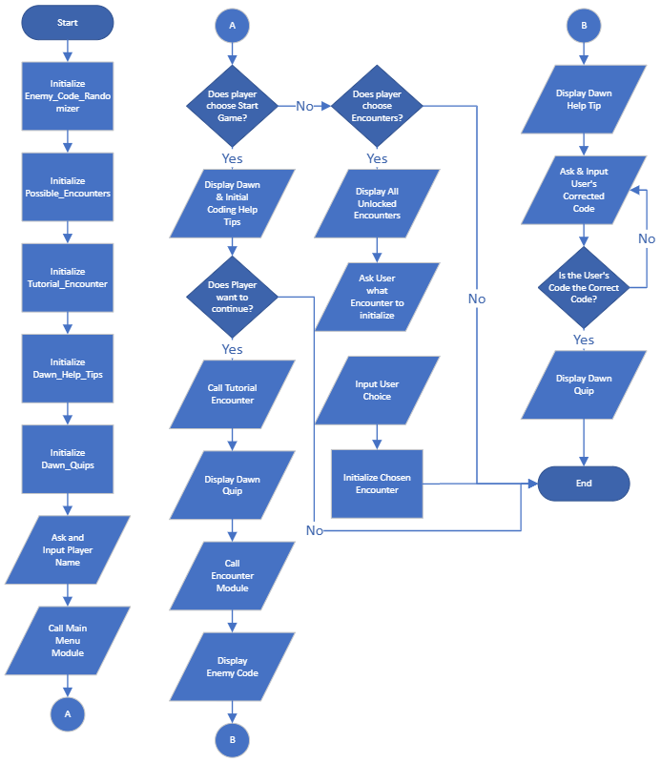

**Python Code:**

*Draft 1 (03 - 30 -2023):*

import random

# Pre-Game Initialization

enemy_code_randomizer = ["Enemy Code 1", "Enemy Code 2", "Enemy Code 3"]

possible_encounters = ["Encounter 1", "Encounter 2", "Encounter 3"]

tutorial_encounter = "Tutorial Encounter"

dawn_help_tips = ["Help Tip 1", "Help Tip 2", "Help Tip 3"]

dawn_quips = ["Dawn Quip 1", "Dawn Quip 2", "Dawn Quip 3"]

player_name = ""

# Main Menu Module

def main_menu():

print("1. Start Game")

print("2. Encounters")

print("3. Exit")

choice = input("Enter choice: ")

if choice == "1":

start_game()

elif choice == "2":

encounter_select()

elif choice == "3":

exit()

# Start Game Module

def start_game():

print("\nWelcome to Code Crawlers!\n")

# Optional feature: Ask for player name

# player_name = input("Enter your name: ")

# Display Dawn & Initial Coding Help Tips

print(

"Dawn: Hello there, " + player_name + "! Welcome to Code Crawlers. Here are some tips to help you along the way:\n")

for tip in dawn_help_tips:

print("- " + tip)

print()

# Call Tutorial Encounter

tutorial()

# Tutorial Encounter

def tutorial():

print(

"Dawn: Let's start with a tutorial encounter, " + player_name + ". This will help you get familiar with the gameplay. ")

print("[Tutorial Encounter Begins]")

print()

# Display Dawn Quip

print(random.choice(dawn_quips))

# Call Encounter Module with Tutorial Encounter

encounter(tutorial_encounter)

# Encounter Select Module

def encounter_select():

print("Unlocked Encounters:")

for i, encounter in enumerate(possible_encounters):

print(str(i + 1) + ". " + encounter)

choice = input("Enter choice: ")

selected_encounter = possible_encounters[int(choice) - 1]

encounter(selected_encounter)

# Encounter Module

def encounter(enemy_code):

# Initialize Enemy Code

correct_code = random.choice(enemy_code_randomizer)

print("Enemy Code: " + enemy_code)

print("Dawn: Here's a hint for you. " + dawn_help_tips[random.randint(0, 2)])

# Start Loop

while True:

# Display Dawn Quip

print(random.choice(dawn_quips))

# Ask & Input User's Corrected Code

user_code = input("Enter your corrected code: ")

# If User's Code == Correct Code, Break

if user_code == correct_code:

print("Dawn: Great job, " + player_name + "! You defeated the enemy.")

break

# Else Restart Loop

else:

print("Dawn: Oops, that's not quite right. Try again.")

# Ask if Player wishes to continue with Y/N

choice = input("Continue? (Y/N): ")

# End Loop if player enters N

if choice.lower() == "n":

return

# Call Random Encounter

encounter(random.choice(possible_encounters))

# Call Main Menu Module

main_menu()

**Output Screenshot:**

*Draft 1 (03 - 30 -2023):*

